**Laptop Request Catalog Item**

**Team ID :** NM2025TMID15025

**Team Size :** 4

**Team Leader :** KATHIRVEL S

**Team member :** ALLWIN JOE J P

**Team member :** KUMARAN S

**Team member :** NITHISH M

**Problem Statement:**

**Employees in the organization need a quick and efficient way to request laptops for work. The current process is manual and prone to delays, with no dynamic form behavior to guide users or ensure accurate data collection. To address this, a Service Catalog item needs to be created, allowing users to easily request a laptop, with dynamic fields, clear instructions, and additional functionality like resetting the form if needed. The solution should also ensure all changes are tracked for governance and deployment.**

**How to Create a Local Update Set in ServiceNow**

1. Open **ServiceNow**.
2. In the left navigation pane, click on **All** and search for **Update Sets**.
3. Under **System Update Sets**, select **Local Update Sets**.
4. Click **New** to create a new update set.
5. Fill in the details:
   * **Name**: Laptop Request
6. Click **Submit**.
7. After submitting, click **Make Current** to activate the update set. 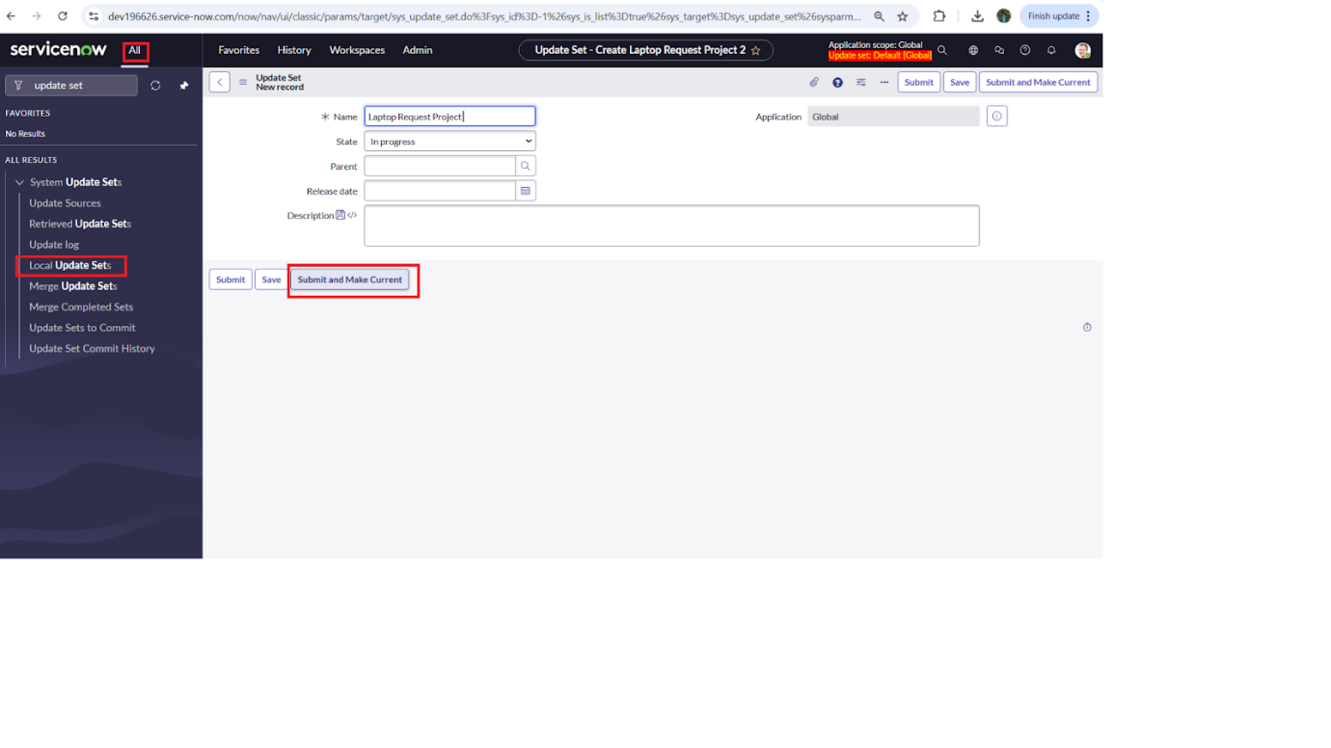

**How to Create a Service Catalog Item in ServiceNow**

1. Log in to **ServiceNow**.
2. In the left-hand navigation panel, click on **All** and search for **Service Catalog**.
3. Under **Catalog Definitions**, select **Maintain Items**.
4. Click **New** to create a new catalog item.
5. Fill in the details as follows:
   * **Name**: *Laptop Request*
   * **Catalog**: *Service Catalog*
   * **Category**: *Hardware*
   * **Short Description**: *Use this item to request a new laptop*
6. Once done, click **Save**. 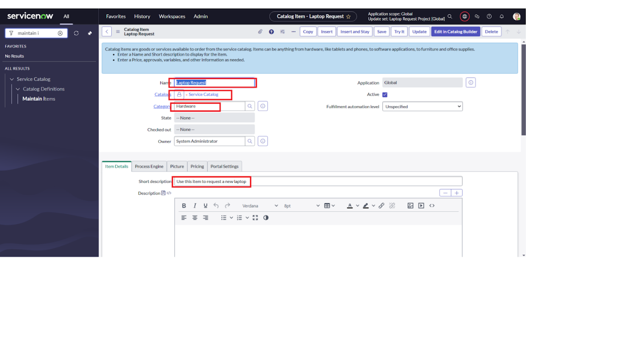

**Adding Variables to the Service Catalog Item**

**Step 1: Create Variables**

1. After saving your **Laptop Request** catalog item, scroll down to the **Variables** section (in the related list).
2. Click **New** and fill in the details for the first variable:
   * **Variable 1: Laptop Model**
     + Type: *Single Line Text*
     + Name: laptop_model
     + Order: 100
   * Click **Submit**.
3. Repeat the same process (**New → Fill details → Submit**) for the remaining variables:
   * **Variable 2: Justification**
     + Type: *Multi Line Text*
     + Name: justification
     + Order: 200
   * **Variable 3: Additional Accessories**
     + Type: *Checkbox*
     + Name: additional_accessories
     + Order: 300
   * **Variable 4: Accessories Details**
     + Type: *Multi Line Text*
     + Name: accessories_details
     + Order: 400

**Step 2: Save the Catalog Item**

* Once all variables are added, scroll back up and **Save** the catalog item form.

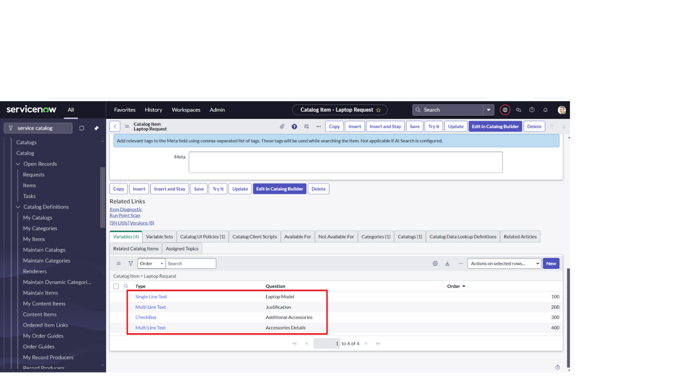

**How to Create a Catalog UI Policy in ServiceNow**

1. Open **ServiceNow**.
2. In the left navigation menu, click on **All** and search for **Service Catalog**.
3. Under **Catalog Definitions**, select **Maintain Items**.
4. Search for the catalog item you created earlier — **“Laptop Request”** — and open it.
5. Scroll down to the **Catalog UI Policies** related list and click **New**.

**Step 1: Define the UI Policy**

* **Short Description**: *Show accessories details*
* In the **When to Apply** section, set the condition:
  + **Field**: additional_accessories
  + **Operator**: is
  + **Value**: true
* Click **Save** do not click Submit yet).

**Step 2: Add a UI Policy Action**

1. Scroll down to the **Catalog UI Policy Actions** related list.
2. Click **New**.
3. Fill in the details:
   * **Variable Name**: accessories_details
   * **Order**: 100
   * **Mandatory**: True
   * **Visible**: True
4. Click **Save**.

**Step 3: Save the UI Policy**

* Finally, click **Save** again on the **Catalog UI Policy form** to confirm everything.

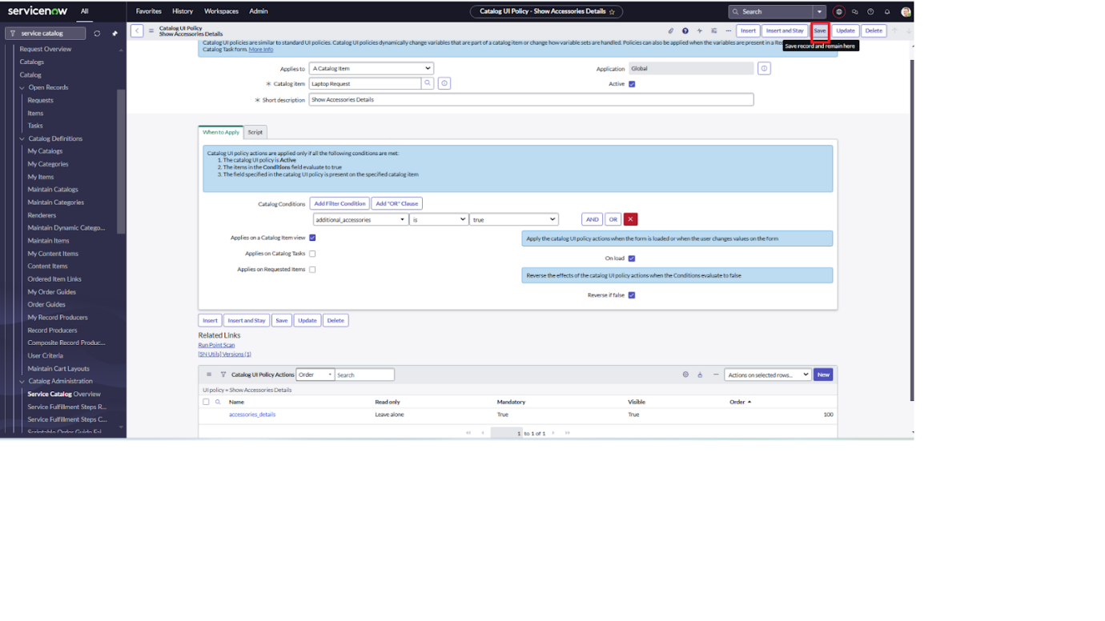

**How to Create a UI Action in ServiceNow**

1. Open **ServiceNow**.
2. In the left navigation menu, click on **All** and search for **UI Actions**.
3. Under **System Definition**, select **UI Actions**.
4. Click **New** to create a new UI Action.
5. Fill in the details:
   * **Table**: Shopping Cart (sc_cart)
   * **Order**: 100
   * **Action Name**: Reset form
   * **Client**: ✅ (checked)
6. In the **Script** field, enter the following:
7. Click **Save**.

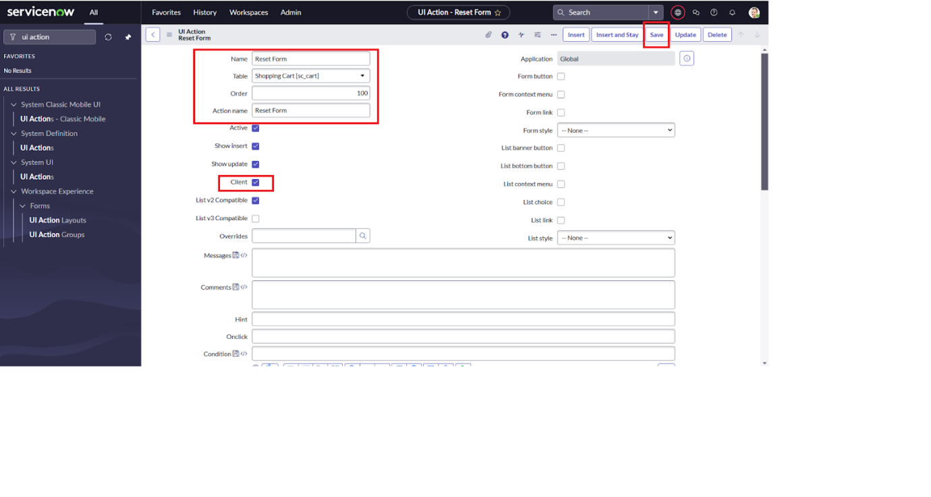

**How to Export Changes to Another Instance in ServiceNow**

1. Open **ServiceNow**.
2. In the left navigation menu, click on **All** and search for **Update Sets**.
3. Select **Local Update Sets**.
4. From the list, open the update set you created earlier — for example, **“Laptop Request Project.”**
5. Change the **State** of the update set to **Complete**.
6. Scroll down to the **Updates** related list. Here, you’ll see all the changes that were captured under this update set.
7. Click **Export to XML**.
   * This will download an XML file containing all the changes.

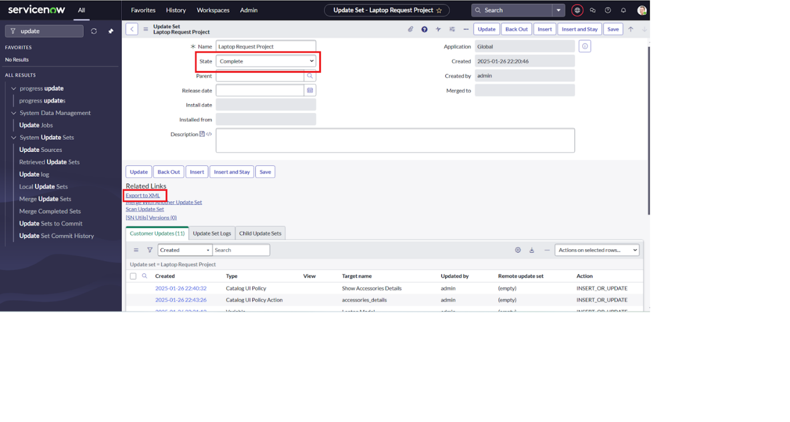

**How to Retrieve and Commit an Update Set in Another ServiceNow Instance**

1. **Open a new incognito/private window and log in to the target ServiceNow instance with your credentials.**
2. **In the left navigation menu, click on All and search for Update Sets.**
3. **Under System Update Sets, select Retrieved Update Sets.**
4. **This opens the list of retrieved update sets. Scroll down and click Import Update Set from XML.**
5. **Select the XML file you downloaded earlier (for example, *Laptop Request Project*) and click Upload.**
6. **Once uploaded, open the retrieved update set — Laptop Request Project.**
7. **Click Preview Update Set to check for any errors or conflicts.**
8. **If everything looks fine, click Commit Update Set.**
9. **After committing, go to the Updates related tab to review all the changes that were applied.**

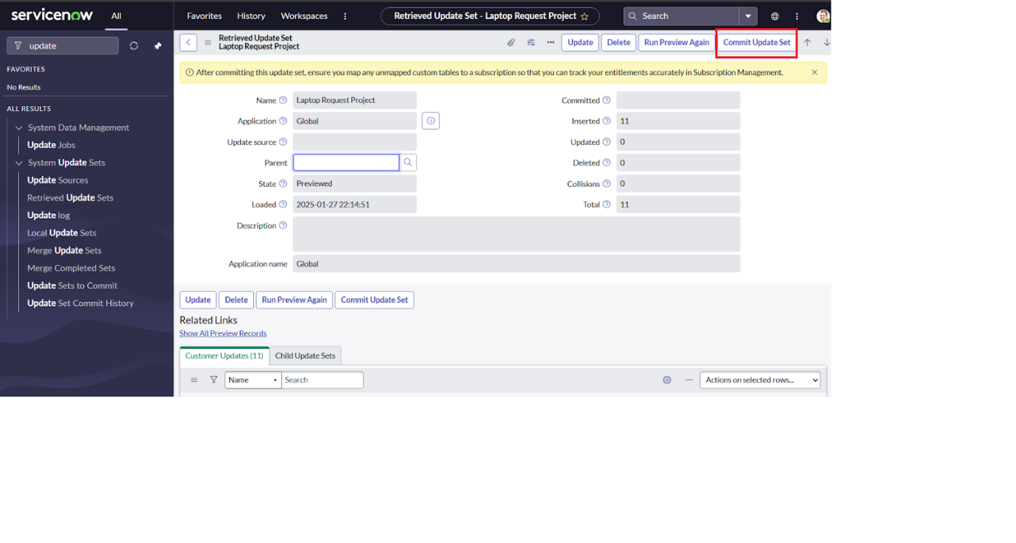

**How to Test the Catalog Item in the Target Instance**

1. In the **target ServiceNow instance**, search for **Service Catalog** in the application navigator.
2. Under **Service Catalog**, select **Catalog**.
3. Open the **Hardware** category.
4. Look for the item **“Laptop Request”** and open it.
5. On the form, you’ll see three variables displayed:
   * **Laptop Model**
   * **Justification**
   * **Additional Accessories**
6. Now, check the box for **Additional Accessories**.
   * The **Accessories Details** field should appear.
   * It should also be **mandatory**, meaning you can’t submit the form without filling it in.

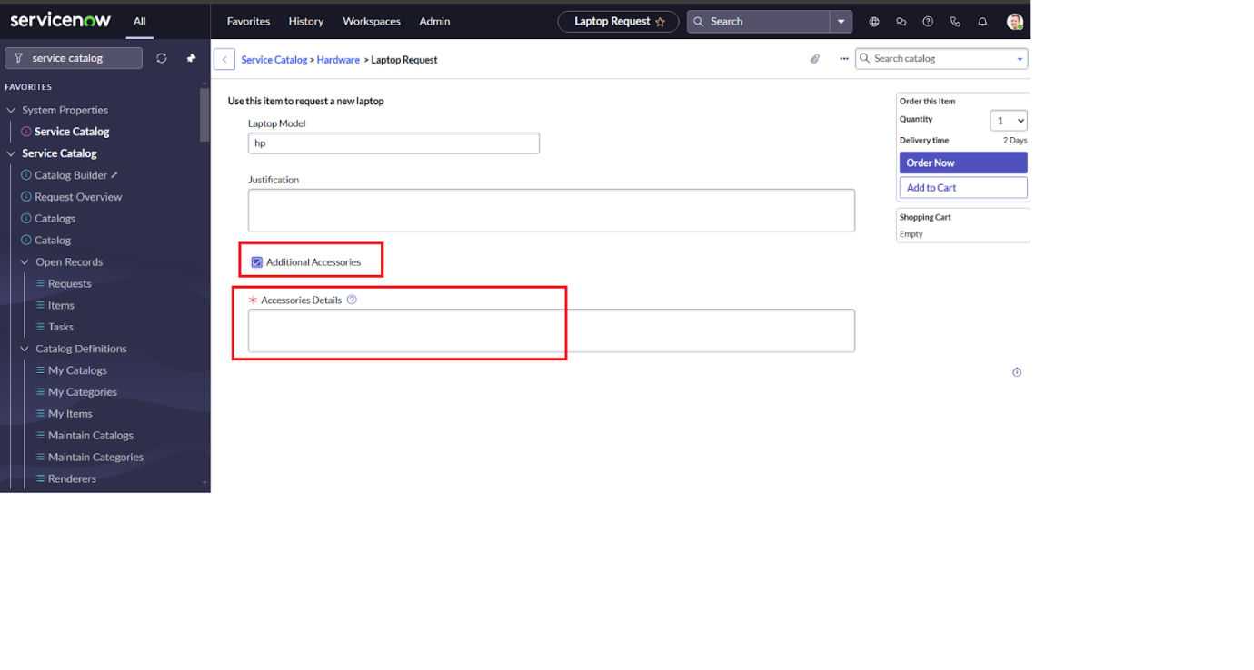

**Laptop Request Catalog Item – Simple Guide**

**1. What is this?**

The **Laptop Request** catalog item is used when an employee wants a new laptop. It collects details like laptop model, reason for request, and if extra accessories are needed.

**2. Create the Catalog Item**

1. Go to **All → Service Catalog**.
2. Under **Catalog Definitions**, click **Maintain Items**.
3. Click **New**.
4. Fill in the form:

* **Name**: Laptop Request
* **Catalog**: Service Catalog
* **Category**: Hardware
* **Short Description**: Use this item to request a new laptop

1. Click **Save**.

**3. Add Variables**

After saving, scroll down to **Variables** and add these one by one:

| **Variable Name** | **Type** | **System Name** | **Order** |
| --- | --- | --- | --- |
| Laptop Model | Single Line Text | laptop_model | 100 |
| Justification | Multi Line Text | justification | 200 |
| Additional Accessories | Checkbox | additional_accessories | 300 |
| Accessories Details | Multi Line Text | accessories_details | 400 |

👉 Add each variable by clicking **New**, filling details, then **Submit**.

**4. Add a Catalog UI Policy**

We want **Accessories Details** to show only when the **Additional Accessories** checkbox is selected.

1. Go to **Catalog UI Policies** → Click **New**.
2. Fill details:
   * **Short Description**: Show accessories details
   * **Condition**: Field = additional_accessories, Operator = is, Value = true
3. Click **Save**.
4. Scroll to **Catalog UI Policy Actions** → Click **New**.
5. Fill details:
   * **Variable**: accessories_details
   * **Mandatory**: True
   * **Visible**: True
   * **Order**: 100
6. Save again.

**5. Move to Another Instance (Update Set)**

1. Create a **Local Update Set** (example: *Laptop Request Project*).
2. Complete your work in this update set.
3. Mark it as **Complete**.
4. Click **Export to XML** → This downloads a file.
5. In the new instance:
   * Go to **Retrieved Update Sets** → Import from XML → Upload the file.
   * Open it → Preview → Commit.

**6. Test the Item**

1. In the new instance, open **Service Catalog → Catalog → Hardware**.
2. Find and open **Laptop Request**.
3. Check the fields:
   * Laptop Model
   * Justification
   * Additional Accessories
4. Tick **Additional Accessories**.
   * Now the **Accessories Details** field appears.
   * It is **mandatory**, so you must fill it before submitting.